**TOURISM MANAGEMENT SYSTEM (TMS)**

**PROBLEM STATEMENT:**

1. **Administrator Access:**

* **Admins** should have the ability to
* **Add Place Details:** Admins can input information about tourist destinations, including descriptions, images, facilities, and availability.
* **View Booking Details**: Admins can access booking records, including user details, dates, and payment status.
* **Verify Bookings**: Admins can verify and confirm bookings made by users.

2. **User Access:**

* **Users** should have the ability to:
* **View Available Places:** Users can explore a list of available tourist places along with relevant details.
* **Book Places:** Users can select their preferred destination, specify travel dates, and make bookings.
* **View Booking Status:** Users can check the status of their bookings (confirmed, pending, or rejected).

**SCOPE:**

The system focuses on:

* **Place Management:**
* Adding, updating, and maintaining details of tourist destinations.
* Ensuring accurate availability information.
* **Booking Management:**
* Facilitating user bookings.
* Providing timely confirmation and communication.
* **User Interaction:**
* A user-friendly interface for seamless interactions.
* Privacy and security of user data.

**DESCRIPTION OVERVIEW**

The Tourism Management System is a software platform designed to revolutionize the travel experience for both administrators and tourists. It acts as a central hub, offering administrators a user-friendly interface to manage destinations, bookings, and information. This includes a comprehensive dashboard with detailed information, and a robust booking management module for smooth reservation oversight.

On the user side, the system provides an immersive and user-friendly interface for browsing through a rich repository of tourist destinations. Each destination is accompanied by vivid descriptions, captivating images, and essential information. Users can leverage the system's search and filter capabilities to tailor their travel exploration based on personal preferences. Booking a location is a seamless process, and users can manage their trips through a personalized dashboard, receiving timely reports and updates for a smooth and enjoyable travel experience.

In essence, the Tourism Management System goes beyond being just a platform. It aims to streamline the tourism industry and create a more efficient and convenient experience for everyone involved, from administrators to tourists.

**TECHNOLOGY USED:**

The Tourism Management System project utilizes a combination of PHP, Visual Studio Code, SQL, HTML, CSS, XAMPP, Apache, and MySQL server to create a comprehensive and efficient platform for managing tourist destinations and bookings.

**SOFTWARE INSTALLATIONS:**

**1. Installation of Visual Studio Code On Windows**

**Step 01:** Visit the official website of the Visual Studio Code and it starts downloading <https://code.visualstudio.com/docs/?dv=win>

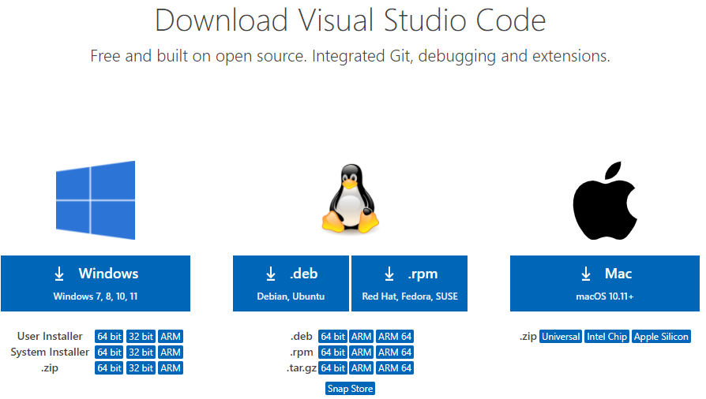

**Fig 1.1**

**Step 02:** Press the “Download for Windows” button on the website to start the download of the Visual Studio Code Application.

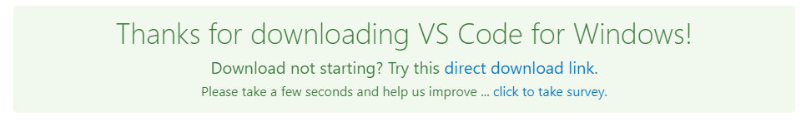

**Fig 1.2**

**Step 03:** When the download finishes, then the Visual Studio Code icon appears in the downloads folder.

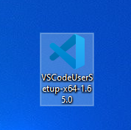

**Fig 1.3**

**Step 04:** Click on the installer icon to start the installation process of the Visual Studio Code.

**Step 05:** After the Installer opens, it will ask you for accepting the terms and conditions of the Visual Studio Code. Click on I accept the agreement and then click the Next button.

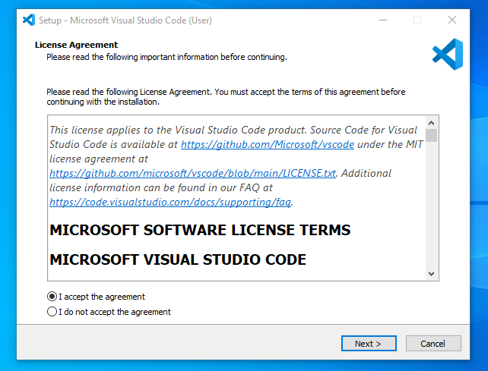

**Fig 1.4**

**Step 06:** Choose the location data for running the Visual Studio Code. It will then ask you for browsing the location. Then click on Next button.

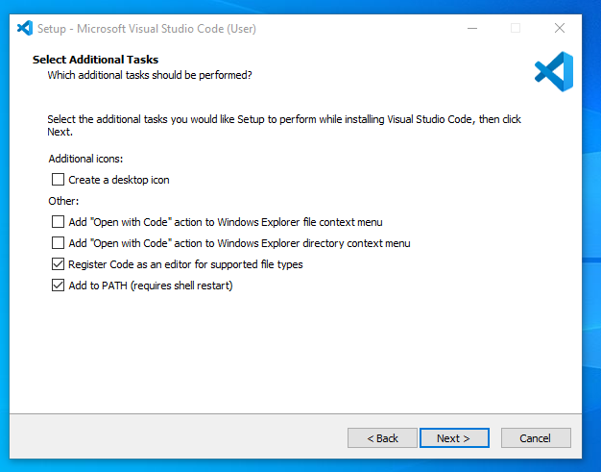

**Fig 1.5**

**Step 07:** Then it will ask for beginning the installing setup. Click on the Install button.

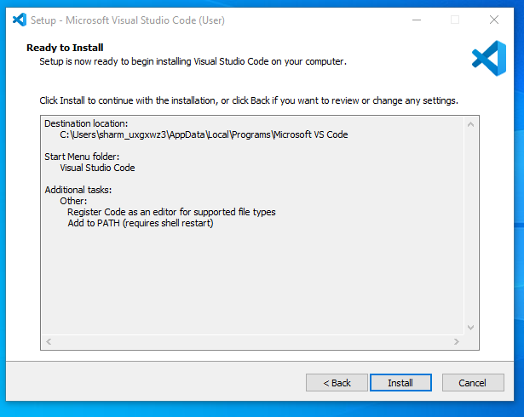

**Fig 1.6**

**Step 08:** After clicking on Install, it will take about 1 minute to install the Visual Studio Code on your device.

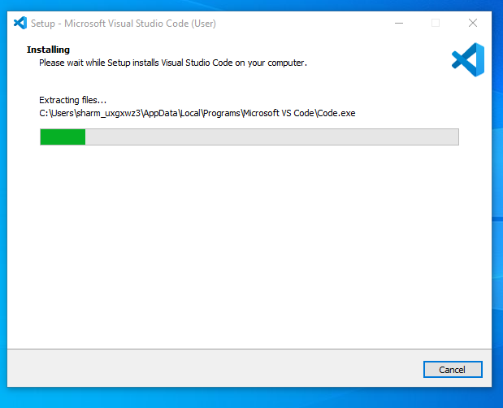

**Fig 1.7**

**Step 09:** After the Installation setup for Visual Studio Code is finished, it will show a window like this below. Tick the **“Launch Visual Studio Code”** checkbox and then click Next.

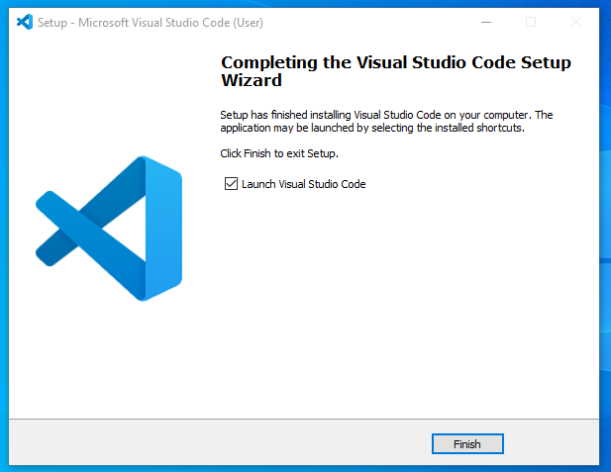

**Fig 1.8**

**Step 10:** After the previous step, the Visual Studio Code window opens successfully. Now you can create a new file in the Visual Studio Code window and choose a language of yours to begin your programming journey!

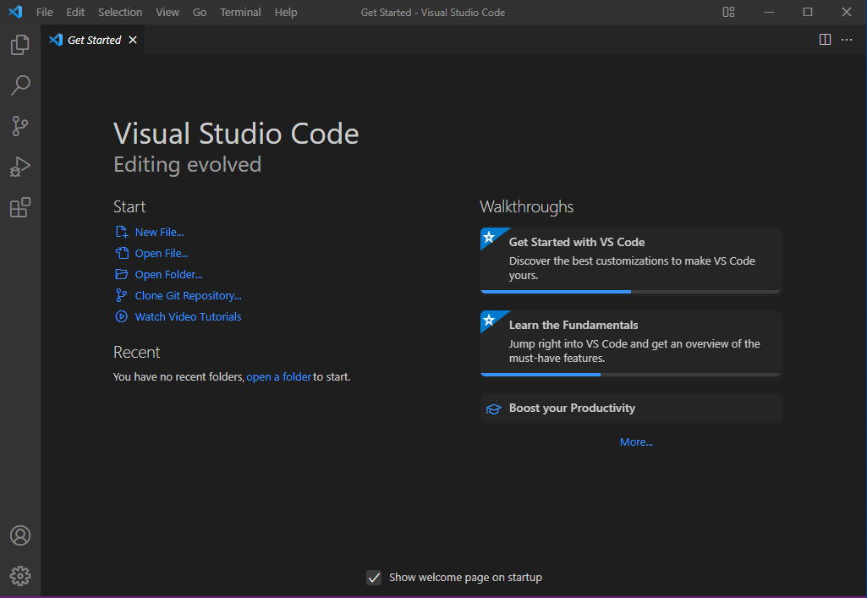

**Fig 1.9**

**2. Install XAMPP on Windows**

**Step 01:** Go to the official XAMPP website and download the latest version of XAMPP for Windows. <https://www.apachefriends.org/index.html>

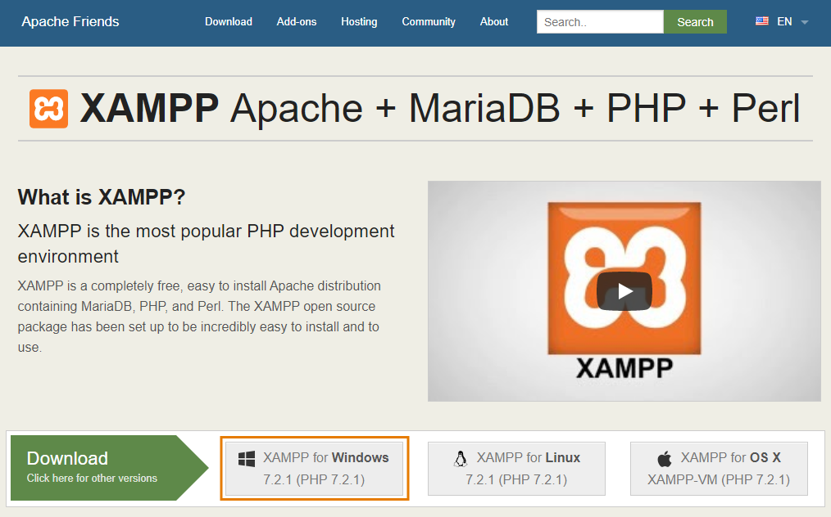

**Fig 1.10**

**Step 02:** Launch XAMPP installer xampp–win32.exe file.

**Step 03:** Some antivirus applications might interfere in the XAMPP installation process. So it is recommended to stop your antivirus application during the installation procedure. After you have stopped the antivirus, select Yes to continue.

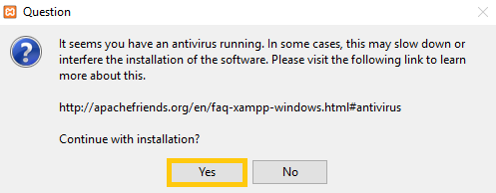

**Fig 1.11**

Step 04: Confirm that you will avoid installing the software to C:\Program Files and press OK. User Account Control (UAC) might block some XAMPP functions when installing to C:\Program Files, so it is recommended to install XAMPP to the default folder.

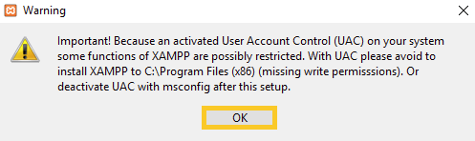

**Fig 1.12**

**Step 05:** Click Next to start the procedure.

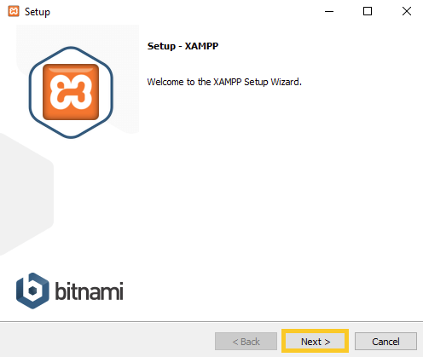

**Fig 1.13**